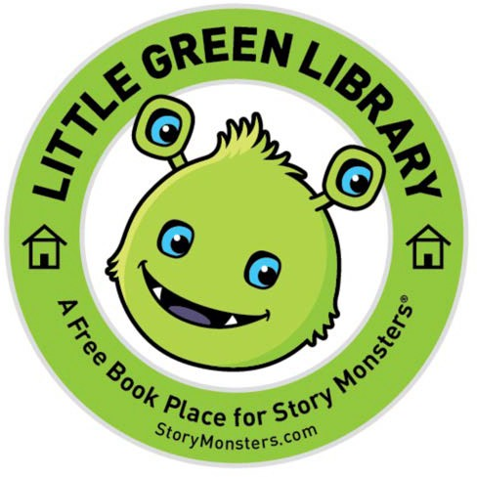
LITTLE GREEN LIBRARY
A Free Book Place for Story Monsters®

Little Green Libraries are a way to encourage the love of reading in all students by providing FREE books for them to enjoy. Story Monsters® will continue to provide FREE books from our authors to the Little Green Libraries as they become available.
Little Green Libraries are distributed to Title 1 schools, children's hospitals, and organizations that support children with special needs. Each Little Green Library comes with 25 new books. Your organization will be added to our list of schools or organizations with a library, encouraging new books to be sent directly to you.
We invite you to complete the form below to join our waiting list for our Little Green Libraries or become a LGL Sponsor.
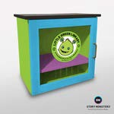
Contact Person: Organization Name: Address:
City: State: Zip Code: Phone Number: Email:

Story Monsters is currently prioritizing Little Green Libraries in Title 1 Schools.

Are you requesting on behalf of s a Title 1 school? Yes No
If no, please indicate your organization.
Would you like to promote our Little Green Libraries at a school or organization function/event? Yes No

ORDERING

The cost for a Little Green Library is $650.
Are you interested in ordering a Little Green Library? Yes No
Do you have partial funding available? If yes, please indicate the amount:
Are you part of a school district? If yes, how many Little Green Libraries would you like to order?

SPONSOR LITTLE GREEN LIBRARIES
Businesses are encouraged to participate in the movement to provide FREE books to children!
Organizations that purchase/sponsor a Little Green Library will have their logo placed on a vinyl seal added to both sides of the library. EXAMPLE: Purchase a Little Green Library at your location and encourage your employees or customers to contribute new books for children. Story Monsters® will deliver your filled Little Green Library to one requested on our waiting list.
Would your organization or business like to sponsor/purchase a Little Green Library? Yes No If yes, how many would you like to sponsor? Or purchase?

LITTLE GREEN BUILDERS
Little Green Builders sponsor books to be included in the Little Green Libraries. Each $49 sponsorship purchases 25 books. The sponsor's name will be placed on a sticker added to each book purchased.
Sponsored books will be distributed to available Little Green Libraries.

Would you like to sponsor new books at a 50% discount to be added to Little Green Libraries? If yes, what amount would you like to contribute?

Questions? Please email Linda@storymonsters.com or call 480-940-8182.
Learn more here: https://storymonsters.com/little-green-library
Thank you for your interest in our Little Green Libraries!
We accept school or business purchase orders, Paypal, and most major credit cards.
Story Monsters LLC – 4696 W. Tyson St., Chandler, AZ 85226 – 480.940.8182

